

REPORT ON

MAKING A CIRCUIT FOR BI-DIRECTIONAL MOTOR

DONE BY

SOUBHIK MAZUMDAR

AIM: To make a circuit using battery, motor and switchs which allow motor to rotate both clockwise and anticlockwise.

COMPONENT REQUIRED: Battery (9V), wires, dc motor, four switches and breadboard.

CIRCUIT DIAGRAM:

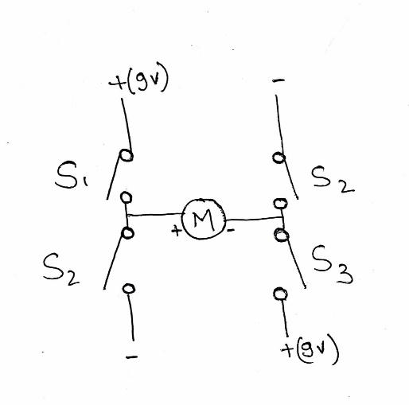

OBSERVATION:

|  |  |  |  |  |
| --- | --- | --- | --- | --- |
| S1 | S2 | S3 | S4 | MOTOR (ROTATION DIRECTION) |
| 1 | 0 | 1 | 0 | CLOCKWISE |
| 0 | 1 | 0 | 1 | ANTICLOCKWISE |

Where,

ON = 1

OFF = 0

PRACTICALLY TESTED:

